Chinese Character Handwriting Recognition for Linux

Annotated Bibliography

Author: Ran CHENG
Student Number: n5105269
Course: Bachelor of Information Technology (Honours)
Supervisor: Jim Hogan
Subject: ITN100 – Research Methodologies

Description of Research
Nowadays, when companies or organizations develop new software, they don’t only target domestic market any more. Instead, they try to develop the software which can be easily internationalized. China, as the top one developing country, is opening their huge market to the world. Linux, as the most challenging Operating System to MS Windows, is trying to spread their advantages to the world. Input method, one of most important factors which influents the marking occupation of OS, is urgently needed to be resolved. Handwriting recognition is one solution for input method, especially for people who have difficulty in learning new input technique to input character into the computer.

Unlike English, Chinese language has more than 10,000 character categories, and more than 50,000 characters. So recognize Chinese character is much harder than recognize English. Chinese character is composed by strokes, and the order or position of the strokes have significant influence on the recognition. In some cases, two or more characters looks very similar, but they have large difference in terms of semantic meaning. Handwriting recognition for English has been researched for ages, but until recent years, handwriting recognition for Chinese started getting popular. Handwriting recognition is sort of pattern classification, for each character, we need some pattern to match. English language only consists of 26 different characters. Chinese language, however, consists of more than 50,000 different characters, even though the most common used characters are more than 1,000. So the pattern we need to recognize Chinese characters are far more than English characters. There are some technologies and algorithms already exist, but most of them doesn’t do good job, in the other words, the quality of recognition are not good.

In this research, we are going to develop some algorithm to recognize Chinese character and delivery some software prototype. Two issues we’ll be trying to resolve are recognition self and recognition quality. There are some mathematic models available to help us to resolve the problems, but we have to find out the best suitable one.

Rabiner, L. R. (1989). A Tutorial on Hidden Markov-Models and Selected Applications in Speech Recognition. Proceedings of the Ieee, 77(2), 257-286.

“A hidden Markov model (HMM) is a statistical model where the system being modeled is assumed to be a Markov process with unknown parameters, and the challenge is to determine the hidden parameters from the observable parameters.” In Essence, HMM is a model whose states are hidden, and by observe the output sequence, we try to find out the states. Three classic problems of HMM are:
- Given observation sequence and model, how to efficiently compute the probability of the sequence.
- Given observation sequence and model, how to choose the corresponding state sequence which best explain the observation sequence.
- Given observation sequence and model, how to adjust the model parameters to maximize the probability of the observation sequence.
More details and solution to those classic questions can be found in the later session of the paper. HMM consists of five elements: the number of states in the model, the number of distinct observation symbols per state, the state transition probability distribution, the observation symbol probability distribution in state and the initial state distribution.

The HMM can be used in the Speech Recognition. The overall recognition system can be divided into five parts: feature analysis, unit matching system, lexical decoding, syntactic analysis and semantic analysis. In terms of speech recognition, noise is one significant factor in the implementation. Three common used ways to handle the noise are:
- Explicitly detecting the presence of speech signal via some techniques.
- Design some model of background silence: signal = silence – speech – silence
- Extend the speech unit models to make the background noise get included.

Relevance to my research:
The tutorial explained the HMM systemically, and let me understand the HMM well. If I use HMM as the model for my search, I’ll try to find out what the states are and what the observation sequences are according to the explanation give in the tutorial. One good thing about this tutorial is that it gave a real implement of the HMM – Speech recognition. Actually, the speech recognition is very similar with my research – handwriting recognition. In theory, by modifying some stuff at the feature analysis stage, I can use the rest of the existing recognition system directly.

Liu, C. L., Jaeger, S., & Nakagawa, M. (2004). Online recognition of Chinese characters: The state-of-the-art. Ieee Transactions on Pattern Analysis and Machine Intelligence, 26(2), 198-213.

This is review paper; it concludes most common existing ways to recognize Chinse Characters. Here is flowchart of Online Chinese character recognition (OLCCR). The whole paper will follow this flowchart and give details of each stage.
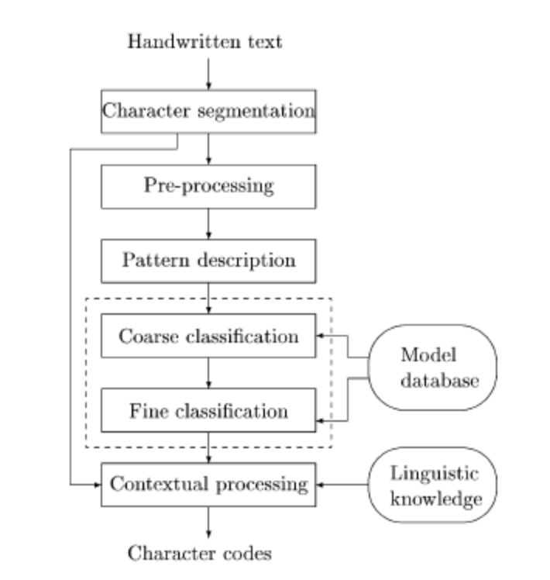
Given a line of Chinese characters, the first thing we need to hand is segment each character. Segmentation can be achieved by character temporal and shape information. Often, boundary between characters can be determined unambiguously, some candidate character pattern can be used to assist the recognition in the Contextual processing stage.

Pre-processing stage include three tasks: noise elimination, data reduction and shape normalization. Some techniques, such as smoothing, filtering, wild point correction, stroke connection, can be used for noise elimination. Data reduction can be achieved by two methods: equidistance sampling and line approximation. Normalization can be accomplished by three approaches: linear normalization, moment normalization and nonlinear normalization.

Pattern description can use three different ways: structural representation, statistical-structural models and statistical representation. Structural representation is most common used way. It consists of four levels from bottom to top: point and line segment representation, stroke code representation, relational representation and structured representation.

Coarse and fine classifications are major parts of the whole recognition system. A good coarse classification can save a lot of time and effort in fine classification. Coarse classification can be accomplished by class set partitioning or dynamic candidate selection. Fine classification can be categorised as DP (dynamic programming) matching, stroke correspondence, relational matching, and knowledge-base matching.

Contextual processing will apply linguistic meaning to the classification. Some language grammar and linguistic meaning can be added to help select the optimal class from this set of candidates. Furthermore, as mentioned in segmentation session, the geometric features of character patterns are useful to segment a hand writing sequence into single characters.

Relevance to my research:
The OLCCR flowchart given in this paper is the common way to implement the Chinese characters handwriting recognition. For each stage in the flowchart, this paper listed several approaches; some of them can be adapted by our research. In the pre-processing stage, three normalisation ways can be used in our research directly. In our research, due to the time constraint, we may not add in grammar to our algorithm, but if we do, the contextual processing session gives us a good guide to do it.

Chang, C.-H. (1994). Word class discovery for postprocessing Chinese handwriting recognition. Paper presented at the Proceedings of the 15th conference on Computational linguistics, Kyoto, Japan.

This paper presents an n-gram model for contextual post-processing of handwriting recognition. The word class of this algorithm is automatically discovered by a corpus-based simulated annealing procedure. Three other language models, least-word, word-frequency and inter-word character bigram model, are used to construct comparison. The experiments are conducted using three large text corpora: 10-million-character 1991ud for collecting character bigrams and word frequencies, 540-thousand-caracter day7 for word class discovery, and 92-thousand-character poli2 for evaluating post-processing language models. This algorithm assumes system has already done all the pre-processing and classification and a set of candidates for input characters have been generated.

“Let T be a text corpus with L words; V be the vocabulary composed of NV distinct words in T; C be the set of classes, where NC is a predefined number of classes. The word class discovery problem can be formulated as follows: Give V and C, find a class assignment ø from V to C which maximizes the estimated probability of T, according to a specific probabilistic language model.”

This word class algorithm adopts simulated annealing approach, which need four elements: a specification of configuration, a random move generator for rearrangements of the elements in a configuration, a cost function for evaluating a configuration and an annealing schedule that specifies time and duration to decrease the control parameter. So the discovery procedure is:
- Initialize: randomly assign the words to the predefined number of classes.
- Move: reassign a randomly selected word to a randomly selected class
- Accept or backtrack: if the result is within controlled limit, the new configuration is accepted, otherwise rollback to upper level
- Loop: iterate the above two steps until find the proper result.

Relevance to my research:
This paper discussed how we should adopt language model in the contextual post-processing stage. Two steps we should take in the contextual post-processing are: using a character recognizer produces top N candidates for each character in the input stream, and using post-processor to find out the best result based on the context and language model. Three large text corpora used in this paper can be candidates in our project.

Liu, J., Cham, W. K., & Chang, M. M. Y. (1996). Stroke order and stroke number free on-line Chinese character recognition using attributed relational graph matching. Paper presented at the Pattern Recognition, 1996., Proceedings of the 13th International Conference on.

This paper introduced a structural method for online recognition of Chinese characters, which is stroke order and stroke number free. As known, Chinese characters consist of a set of complex strokes. By investigating the relationship between strokes, this paper introduced the Attributed Relational Graphs (ARGs).

The relation R_{ij} between segment i and j can be represented as a vector R_{ij} = (a¹_{ij}, a²_{ij}, a³_{ij}), where a¹_{ij}, a²_{ij}, a³_{ij} are in the range {Chen, 1996, 2}. For a¹_{ij}, 0, 1 or 2 denotes segment i being “below”, “above”, or “below or above” segment j. For a²_{ij}, 0, 1 or 2 denotes segment i being on the “right of”, “left of” or “right or left of” segment j. For a³_{ij}, 0, 1, 2 denotes segment i “uncrosses”, “crosses” or “uncrosses or crosses” segment j.

The procedure of recognition can be described as: give an unknown pattern (or character), system will transform this pattern into an ARG and then matching the ARG with those which represent the structures of model patterns. According to this algorithm, since we only need consider the relationship between each stroke, stoke order and stoke number free can be achieved. The matching procedure is formulated as a search problem of finding the minimum cost path in a state space tree, using the A* algorithm.

Relevance to my research:
This is one of few papers which try to recognize Chinese Character using stroke order and number free method. One of our theoretical goals of our research project is trying to achieve stroke order and number free. The ARGs introduced in this paper may be able to be used in our research.

Ge, Y., Guo, F.-J., Zhen, L.-X., & Chen, Q.-S. (2005). Online Chinese character recognition system with handwritten Pinyin input. Paper presented at the Document Analysis and Recognition, 2005. Proceedings. Eighth International Conference on.

The Chinese handwriting recognition system developed in this paper can recognise Chinese character by handwritten script or Pinyin syllable (The Pinyin based input method is sort of text input method that utilizes the mapping from a Pinyin syllable to Chinese characters). Two problems which can be resolved by this method are:
- When the user forgets how to write the desired character or
- When the desired character is too complex to be written conveniently.
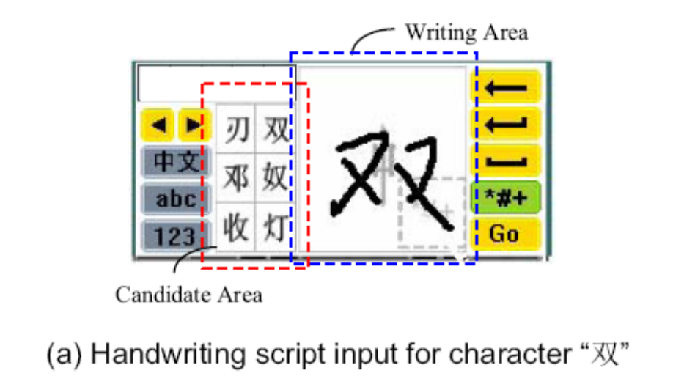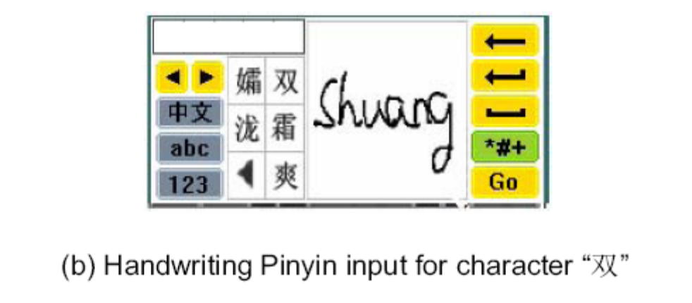
The picture shows the two different way to input “双”.
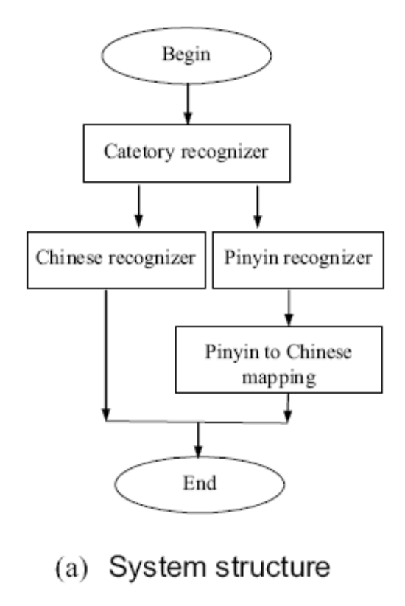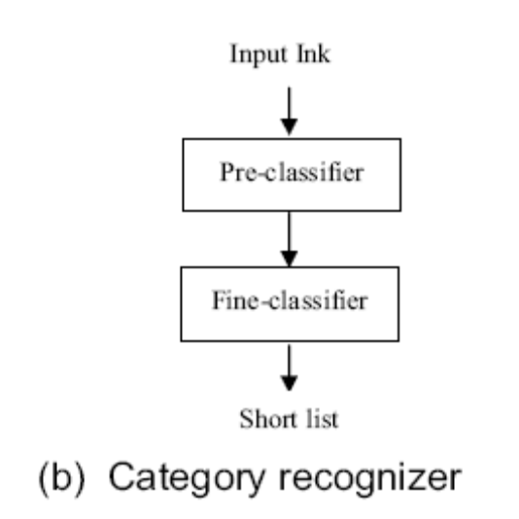
A category recognizer is applied to determine whether the input ink is a character or Pinyin syllable. One good thing here is the final recognition result candidates are sorted in the order of character frequency. Two classifiers used in this algorithm is pre-classifier and fine-classifier. Pre-classifier will select up to 1000 candidates, then the fine-classifier will resort the 1000 candidates set.

Actually, the key part of this algorithm is the category recognizer. One HMM (Hidden Markov Model) classifier and one TM based classifier are used to recognize user’s input. HMM classifier is used to capture the temporal information. The TM based classifier is used to capture the shape information.

Relevance to my research:
The idea of using category recognizer can be adapted in our research. This paper is from Motorola Labs, China Research Center, as the commercial lab, when we develop the algorithm, usability and easy implementation of software are the main goals. This situation is similar to our research, since our research is sponsored by Redhat Linux. So the way they conduct their research can give some guide to us.

Chen, J.-W., & Lee, S.-Y. (1996). On-line handwriting recognition of Chinese characters via a rule-based approach. Paper presented at the Pattern Recognition, 1996., Proceedings of the 13th International Conference on.

This paper presents a rule-based approach for online Chinese character recognition without writing constraints on both stroke number and order. This approach recognizes all possible basic stokes in an input before stroke correspondence, and connected strokes can be segmented apart if exist.
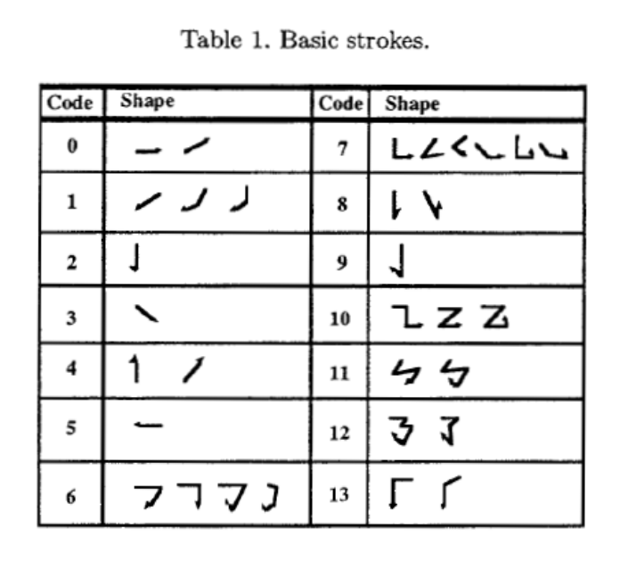
The picture above shows the basic strokes defined by this algorithm. Each handwritten input character is first processed by the stage of preprocessing, in which the line-segment representation can be acquired from the series of point data with noise. The distances between these candidates and the input script will be calculated in the stage of structural analysis. The candidate with minimum distance is the recognition result. The structural analysis includes three processing steps: stoke correspondence, distance calculation, and detailed recognition.

There are some predefined rules with each basic stroke. Using a Chinese character as Example, “王” consists of fours strokes, and the corresponding stroke type are 0 – 0 – 2 – 0. So four rules can be applied to these strokes:
- The stroke with stroke type 0, and its center point with the minimum Euclidean to the left-top cornet point of the character.
- The stroke with stroke type 2 and the top boundary of its MBR with the maximum y coordinate.
- The stroke with stroke type 0 and its center point with the minimum Euclidean to the left-bottom corner point of the character.
- The stroke with stroke type 0 and the top boundary of its MBR with the maximum y coordinate.

Relevance to my research:
The rule-based approach seems not be able to adapted by our research, but this algorithm try to recognize Chinese character stroke by stroke instead of recognize the whole character. The common used Chinese characters are more than 1000, but the number of stroke is less 30. If we can use the similar approach in our research (recognize the stroke), our research may be easy to be adopted by future project.

Liu, Y. J., & Tai, J. W. (1988). A structural approach to online Chinese character recognition. Paper presented at the Pattern Recognition, 1988., 9th International Conference on.

This paper investigate Chinese characters in a very detail way. It categories Chinese character into four levels: whole character level, parts of character level, stroke level and Line segment level. Some strokes or straight line segments can be considered as a set of primitives, and production rules can also be found according to the properties of characters. In this paper, a fuzzy attributed finite state grammar and corresponding automation are introduced for recognizing line segments. It’s reasonable to realize a set of similar hand writing strokes should be a fuzzy set, and by means of fuzzy information processing technique, a fuzzy attributed finite state grammar can be defined. The point view of a fuzzy attributed grammar is embedding a regular stroke into a set o distorted strokes with different structure, then the membership function is considered as a similarity measure for character classification, which is better than a distance measure. The reason is that the structure of distorted strokes may be different from structure of regular stroke. The high recognition rate is hardly to obtain by error correcting technique.

Relevance to my research:
This paper is quiet old, and most references used by this paper are from same author. So the technique used by this paper seems a little bit limited. But this paper analyzes structure of Chinese character in a very detail way, especially the four levels classification, which can be a good guild to our research.

Chang, J.-Y., & Wan, M.-H. (1998). Fuzzy stroke type identification for online Chinese character recognition. Paper presented at the Systems, Man, and Cybernetics, 1998. 1998 IEEE International Conference on.

This paper presents an online Chinese character stroke type recognition system based on
Fuzzy set theory. Some other technique, such as Modified Dynamic programming forward matching, Modified Dynamic programming backward matching, and A* matching algorithms, are used with this stroke type identification schema to build the whole recognition system. This recognition system transforms all input characters into a set of basic strokes. Then use fuzzy set theory to recognize the set of strokes. Fuzzy set theory has been approved as an appropriate framework to address many of the problems encountered in handwriting recognition, because various kind of variation found in handwriting characters can be resolved by fuzzy logic and consequently the constraints of careful writing can be greatly released.

This recognition system workflow is:
- Extract the angle of a stroke segment directly.
- For each stroke type, define the angle membership functions as features to measure the degree of similarity for input strokes.
- Recognize input character as a sequence of primitive strokes.
- Based on stroke type identification schema, use Modified Dynamic Programming forward matching, Modified Dynamic Programming Backward matching, and A* matching algorithms, to construct a character recognition system to best match the input script to the reference stroke database.
- Results of three matching algorithms are fused with fuzzy integral technique, and the character with maximum confidence value is recognized as the target character.

Relevance to my research:
Most recognition systems or algorithms use direction codes to represent a stroke segment and then identify the input stroke by performing the feature matching between the given segment string and section string of input stroke, but this algorithm didn’t follow that way. It’s good to develop new algorithm which jump out the cage. For our research, the Fuzzy integral technique could be another option which we can adopt.

Hasegawa, T., Yasuda, H., & Matsumoto, T. (2000). Fast discrete HMM algorithm for online handwriting recognition. Paper presented at the Pattern Recognition, 2000. Proceedings. 15th International Conference on.

This paper proposed a fast Discrete HMM algorithm for online handwriting character recognition. After pre-processing, this system transform the each whole character into discretized strokes, then HMM is used. The discretization naturally leads to a simple procedure for assigning initial state and state transition probabilities. Two great challenges problem in online handwriting recognition which this algorithm try to conquer are:
- Stroke number variations, stroke connections and shape variations.
- Stroke order variations.

This algorithm can be divided roughly into pre-processing and post-processing. In the pre-processing, each character is transformed into strokes, and then each stroke is quantized into discrete dots. In the post-processing, Discrete HMM is structured for online handwriting recognition firstly. In handwriting and speech recognition, the left to right model of HMM model is most frequently used, and here the algorithm uses this model too. After the HMM structure stage, the system will come to the Recognition and learning stage. Learning and recognition are closely related in HMM. The system proposes some recognition schema based on some HMM formula, and then starts the learning procedure. In the learning procedure, the first model is generated, then use it to compare with multiple training data set, and finally, the best result will be used to generate final model.

A drawback of this algorithm is when the number of character classes and their associated models becomes large, a large memory is required.

Relevance to my research:
HMM model is the most possible mathematic model we are going to use in our research project. This paper shows us how to use Discrete HMM model in the online handwriting recognition system, which give some valuable practice guide. Especially, the quantization processing will be able to be adopted by our research project if we use HMM model. This paper already listed one drawback of HMM model in their approach, so we can try to find some way to get around it.

Nakai, M., Akira, N., Shimodaira, H., & Sagayama, S. (2001). Substroke approach to HMM-based on-line Kanji handwriting recognition. Paper presented at the Document Analysis and Recognition, 2001. Proceedings. Sixth International Conference on.

This paper proposed a new method for online handwriting recognition of Kanji characters. The minimum unit used in this algorithm is sub-stroke HMM. The main goal of this algorithm is to fully utilize the continuous speech recognition algorithm by relating sentence speech to Kanji character, phonemes to sub-strokes, and grammar to Kanji structure. This recognition system consisted of input features, sub-stroke HMMs, recognition, and invoke hierarchical Kanji Dictionary and a decoder.

Five advantages of this system are:
- much smaller memory requirement for dictionary and models
- fast recognition by employing efficient sub-stroke network search
- capability of recognizing characters not included in the training data if defined as a sequence of sub-strokes in the dictionary
- capability of recognizing characters written by various different stroke orders with multiple definitions per one character in the dictionary
- easiness in HMM adaptation to the user with a few sample character data.

This system started from accepted input from pen, the pen positions (x, y) is the primary information. A set of positions are stored in some place, then use it as the input at substroke HMM stage. By using some HMM formulas, recognition was carried out. At Hierarchical Kanji Dictionary stage, a hand-made dictionary was used to recognize the character further.

Relevance to my research:
Although this paper proposed an approach for Japanese Kanji handwriting recognition, because of the close relationship between Kanji and Chinese Character, this paper is still considerable. At the last stage of this algorithm, it invoked some hand-made dictionary to further recognize the character, which may lead to some error, but still is good idea. This is the first paper I read which invoke dictionary and grammar.

Kim, H. J., Kim, K. H., Kim, S. K., & Lee, J. K. (1996). Online Recognition of Handwritten Chinese Characters Based On Hidden Markov Models. Pattern recognition (Pattern recogn.), 30(9), 1489-1500.

This is paper propose a recognition model of online cursive Chinese characters based on HMMs. The model is constructed as character recognition network composed of radical and ligature HMMs supposing that a Chinese character is a set of consecutive and meaningful radials. The network represents information for the large character set: nodes describe the structural information of radials which can be shared and reused by another character, and a path from the initial state to the final state represents a complete character. In this case, the large character set can be represented by a small number of HMMs and cursive characters are recognized in a way that accommodates variations in personal writing styles without stroke segmentation. Character recognition in this system is regarded as a network search which finds the optimal path with maximum probability, but a network for the Chinese character has so many paths to cover all the possible characters that an entire search cannot meet the expectation due to the computation. To speed up the recognition, this system uses a modified level building search procedure. The modified level building evaluate all existing paths, the algorithm once evaluates each HMM on level using the Viterbi algorithm, then decides an appropriate radical on that level by backtracking. As the consequence, the performance of the algorithm is governed only by the number of levels in the network, and is appropriate for the recognition network of Chinese characters.

Relevance to my research:
This is another HMM based handwriting recognition algorithm. Besides considering how to apply HMM to the handwriting recognition, this algorithm also cope the efficiency of using HMM. So for our research, we can also try to consider the efficiency of recognition by referencing this paper.

Tappert, C. C., Suen, C. Y., & Wakahara, T. (1990). The state of the art in online handwriting recognition. Pattern Analysis and Machine Intelligence, IEEE Transactions on, 12(8), 787-808.

This is a review paper and it’s based on an extensive review of the literature, including journal articles, conference proceedings, and patents. This paper examined the online handwriting recognition from the several different perspectives, such as shape recognition, pre-processing and post-processing techniques, experimental systems and commercial products.

Online handwriting recognition requires a transducer that captures the writing as it is written. The most common of these devices is the electronic tablet or digitizer. By contrast, offline handwriting recognition is performed after the writing is completed. It can be performed days, months, or years later.

No matter what algorithm is used for the recognition, pre-processing should be taken. Normally, the pre-processing consists of external segmentation, noise reduction and normalization.

Several different strategies can be used to recognize the character shape. Here is some example of them:
- Character recognition:
  - feature analysis,
  - time sequence of Zones, Directions, or Extremes
  - Curve Matching
  - Stroke codes
  - Analysis by synthesis
- Recognition of Character sequences
- Recognition of Cursive Script
- Recognition of Words
- Recognition of Gestures
- Recognition of Equations and Line Drawings
- Signature verification

Some commercial systems are available at the market, and this paper listed some of them, and discussed the advantages and disadvantages of each product.

Relevance to my research:
This is the second review paper I read. Different from the previous review paper, this one discussed the general handwriting recognition instead of Chinese character. By reading the paper, I learned some other technologies which are available for other language, which just open my mind, let me think out of the box. At the end of the paper, it discussed the robust algorithms for recognition, which may be able to put into our project plan for future development.

